
East West University
Lab Report
Semester: Summer-2025
Course Title: Electronic Circuits Course Code: CSE251
Section: 04

Expt No: 06
Expt Name: Signal Integration and Differentiation using 741 Op Amp
Group No: 06
Group Members:
Student Name | Student Id
Md. Hasib Ali | 2023-3-60-186
Arijit Kumar Anoy | 2023-3-60-055
Md. Shakib Al Hasan | 2024-1-60-200
Fahim Shahriar | 2023-2-60-094
Morshedul Islam | 2023-2-60-125

Submitted by-
Name: Md. Shakib Al Hasan
Id: 2024-1-60-200

Submitted to-
Dr. Sarwar Jahan
Associate Professor
Department of Computer Science & Engineering
East West University

Date of Performance: August 11, 2025
Date of Submission: August 18, 2025
Title: Signal Integration and Differentiation using 741 Op Amp

Objectives
1. To study the response of 741 Op Amp Integrator to sinusoid and square waveforms.
2. To study the response of Op-Amp differentiators to sinusoid and triangular waveforms.

Theory (Summary)
An operational Amplifier (Op-Amp) is a differential amplifier that performs mathematical operations such as addition, subtraction, integration, differentiation, etc. In Expt. No. 3, we use the Op-Amp with the only resistors to study adder and amplifier circuits. In this experiment, we will study integrator and differentiator circuits by using a capacitor either in the feedback or input path.

Equipment and Component
1. Digital trainer board
2. Signal generator
3. Oscilloscope
4. Digital multimeter
5. 741 Op Amp (1 pc)
6. Resistor (1ΚΩ 1 pc)
7. Capacitor (0.1µF, 1 pc)
8. Breadboard
9. Connecting wires

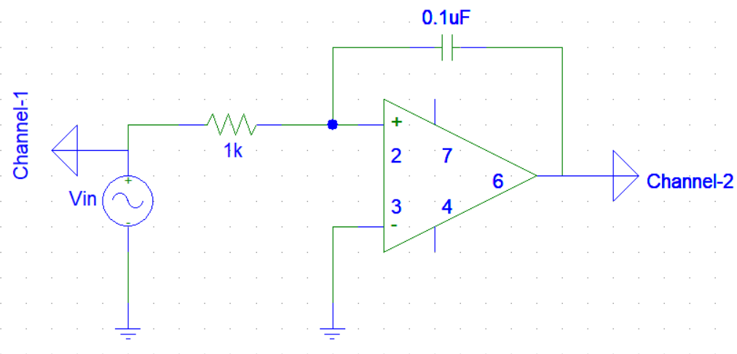
Circuit Diagram

Figure-1: An Op Amp integrator circuits.
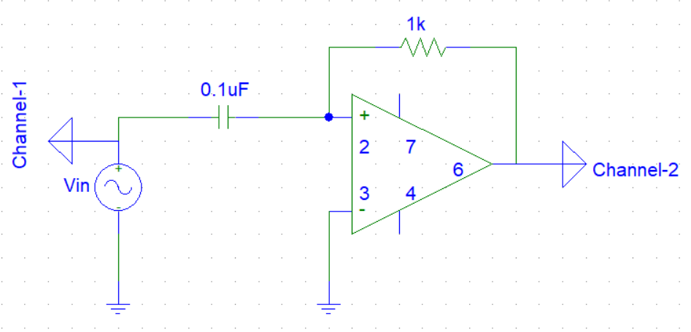

Figure-2: An Op Amp differential circuits
Pre-Lab
1. INTEGRATOR: Consider the integrator shown in Figure_1 with $V_{in} = V_{P}sin(ꞷt)$. If the circuit is initially relaxed, find the expression of output and determine the frequency, f, at which the output amplitude is equal to 2$V_{P}$. Also, determine the phase relation between input and output.
Answer
Integrator Circuit Given
Input: $V_{in}=V_{P}sin(ꞷt)$
Resistor: R = 1KΩ = 1000Ω
Capacitor: $C=0.1µF=1×{10}^{-7}F$
Output Expression:
For an ideal op-amp integrator, the output is:
$$V_{out}\left(t\right)=-\frac{1}{R_{c}}∫V_{in}\left(t\right)dt$$
Substitute, $V_{in}\left(t\right)=V_{P}sin(ꞷt)$
$$V_{out}\left(t\right)=-\frac{V_{P}}{RCω}cos(ꞷt)$$
So, the output is a cosine wave with a phase shift of $-{90}^{0}$(lagging input by ${90}^{0}$), and
amplitude $V_{out}=\frac{V_{P}}{RCω}$
Now when output amplitude $= 2V_{P}$
⸫ $\frac{V_{P}}{RCω}=2V_{P}$
Or, $2πf=\frac{1}{2RC}$
Or, $f=\frac{1}{4πRC}=\frac{1}{4π×1×{10}^{-7}×1000}=795.7747Hz$

Phase Relation; Output lags the input by ${90}^{0}$

2. DIFFERENTIATOR: Consider the differentiator shown in Figure 2 with $V_{in}=V_{P}sin(ꞷt)$. in If the circuit is initially relaxed, find the expression of output and determine the frequency, f, at which the output amplitude is equal to V, 12. Also, determine the phase relation between input and output.
Answer
Differentiator Circuit Given
Input: $V_{in}=V_{P}sin(ꞷt)$
Resistor: R = 1KΩ = 1000Ω
Capacitor: $C=0.1µF=1×{10}^{-7}F$
Output Expression:
For an ideal op-amp integrator, the output is:
$$V_{out}\left(t\right)=-RC\frac{d}{dt}V_{in}\left(t\right)$$
Substitute, $V_{in}\left(t\right)=V_{P}sin(ꞷt)$
$$V_{out}\left(t\right)=-ꞷRCV_{p}cos(ꞷt)$$
So, the output is a cosine wave with a phase-shifted $-{90}^{0}$(lagging input by ${90}^{0}$), and
amplitude, $V_{out}=-ꞷRCV_{p}$
Now when output amplitude $=\frac{V_{P}}{2}$
⸫ $ꞷRCV_{p}=\frac{V_{P}}{2}$
Or, $2πf=\frac{1}{2RC}$
Or, $f=\frac{1}{4πRC}=\frac{1}{4π×1×{10}^{-7}×1000}=795.7747Hz$

Phase Relation: Output lags the input by ${90}^{0}$

Post-Lab

INTEGRATOR:
1. In the output expression from your prelab, put the measured value of R and the given values of C and $V_{P}$; calculate the amplitude of the output signal and compared it with the measured data.
Answer
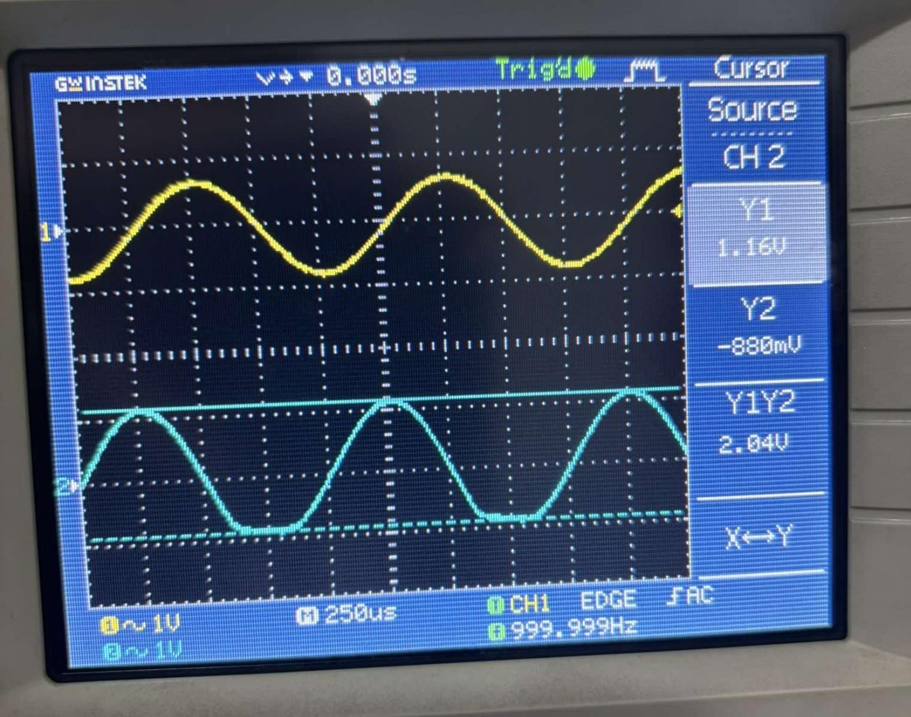

Here,
R = 1KΩ = 1000Ω
$$C=0.1µF=1×{10}^{-7}F$$
$V_{P}=2V$
f = 1000Hz
We know,
Amplitude, $V_{o}=\frac{V_{P}}{ωRC}=\frac{V_{P}}{2πfRC}=\frac{1}{2π×1000×1000×1×{10}^{-7}}=3.18V$

Comparison between the measured & calculate the amplitude:

 | Calculate Value | Measured Value | Discrepancy
Amplitude | 3.18 | 2.04 | 35.849%
2. Compare the phase relation between your prelab result and measured data.

Answer
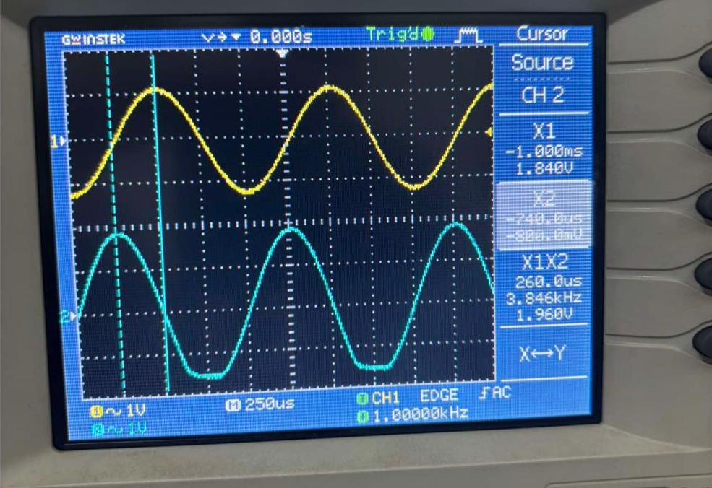

Here,
∆𝑡 = 260µ𝑠
f = 1000Hz

⸫ $∆θ={360}^{0}×∆t× f$
$={360}^{0}×260us×1000=93.6°$

Comparison between the measured & prelab values of the phase difference:

 | Prelab Value | Measured Value | Discrepancy
Phase Relation | $${90}^{0}$$ | $${93.6}^{0}$$ | 4%

3. Simulate the integrator of Figure-1 for 4 cycles using PSpice with the measured value of R and the square wave input that you have used in the lab and have the simulation result printed. Compare the simulation result with your measurement.
Answer
Operation of Op Amp Integrator:
Integration of Sinusoidal Voltage:
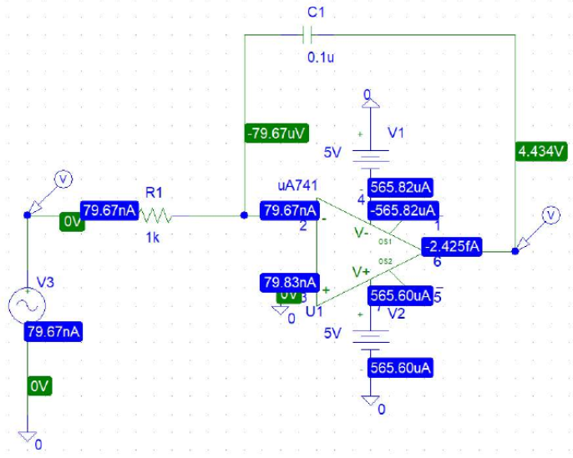

Simulation Result:
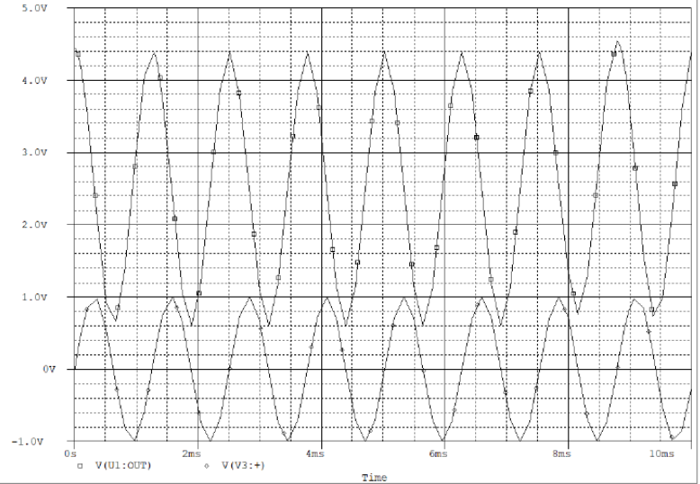

Integration of Square wave Voltage:
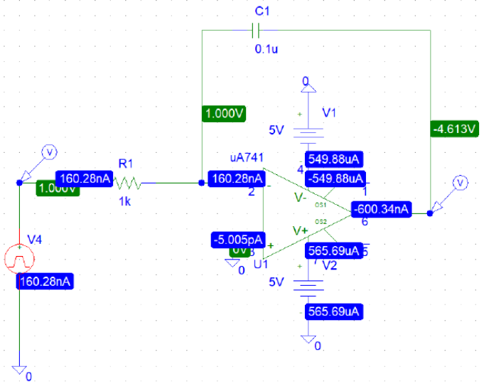

Simulation Result:
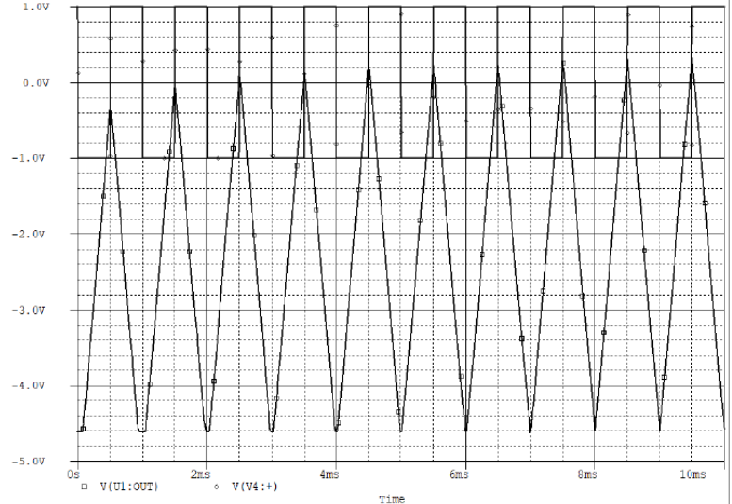

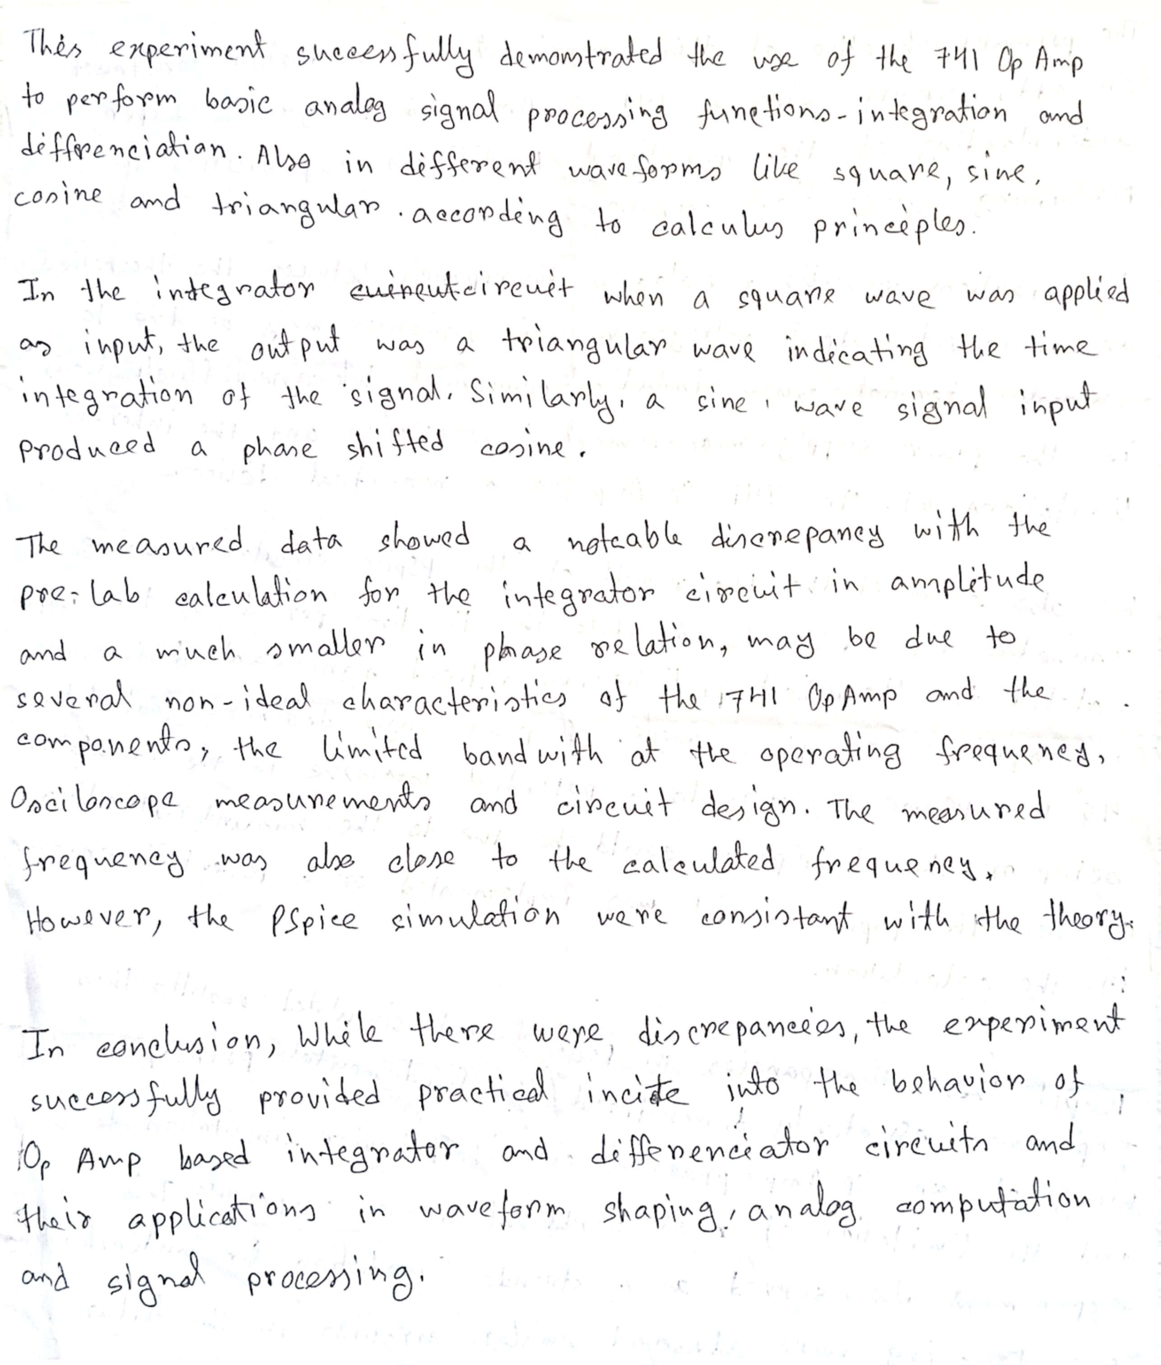
Discussion

